1. 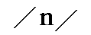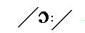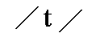
night
nut
not
nought
2. 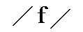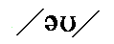
phone
fawn
fan
fern
3. 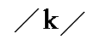
cook
Coke
cake
cork
4. 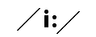
chef
chief
chafe
shave
5.
air
ear
our
or
6. 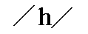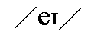
hat
hate
hoot
hut
7. 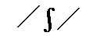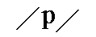
sheep
ship
shape
shop
8. 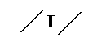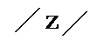
fizz
fuzz
fuss
face
1. 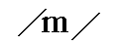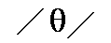
moth
mouth
month
math
2. 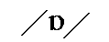
ship
sip
seep
shop
3.
fat
fit
feet
fought
4. 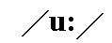
shoe
show
Shaw
she
5. 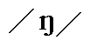
king
kin
Kong
Cone
6. 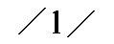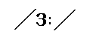
lean
learn
lend
lain
7.
moon
mean
moan
main

8. 
seen
son
sun
soon
1. 
nip
neap
nap
nape
2. 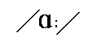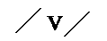
cave
cove
carve
curve
3. 
Jim
game
gem
germ
4.
out
art
eat
oat
5. 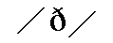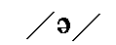
though
the
there
they
6.
pitch
pig
pish
pith
7.
see
key
sea
Kay
8.
puck
pack
poke
peak
Phonetic descriptions: Part 5 (Koen Van Cauwenberge)
Gap-fill exercise.
Give for each phonetic description the correct English word.
Phonetic description | English word
1.
2.
3.
4.
5.
6.
7.
8. 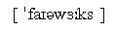
9. 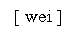
10. 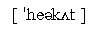

Give for each phonetic description the correct word.

Phonetic  description | Give  the corresponding word
01.
02.
03.
04.
05.
06.
07.
08.
09.
10.
11.
12.
13.
14.
15.

Phonetic descriptions: Kinds of houses (Koen Van Cauwenberge)
Gap-fill exercise
Give for each phonetic description the correct word.

Phonetic  description | Give  the corresponding word
01.
02.
03.
04.
05.
06.
07.
08.
09. 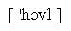
10.
11.
12. 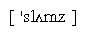
13. 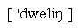
14. 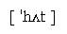
15.

Please log in to save your progress.

1.  .
2. .
3.  .
4. ?
5.  .
6. 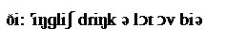 .
7. 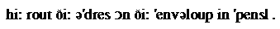 .
8.  .
9. .

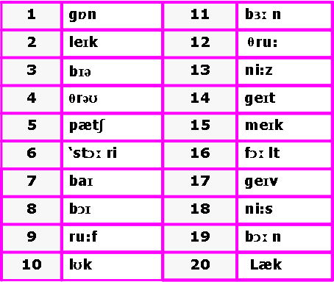

1
2. 
3.
4. 
5. 
6. 
7. 
8.
9.
10. 

- 
2. 
3. 
4. 
5. 
6.
7. 
8. 
9. 
10. 

- 'meilbæg
2. pi:s
3. praud
4. re'vendz
5. dis'deinful
6. 'nju:bail
7. ''fa:stnis
8. 'klouðzpin
9. 'bækeik
10. ˈwɛlθɪ

1. di'fensiv
2. mægnitaiz
3. straik
4. nju:mætik
5. ri'spekt
6. ri'zaund
7. trænz'mit
8. snaip
9. wið
10. ri'moutnis

1.
2. 
3. 
4. 
5. 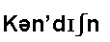
6. 
7.
8. 
9. 
10. 

1. 
2. 
3. 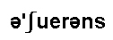
4. 
5. 
6. 
7.dæmɪdʒ
8. 
9. 

1. ek'sesiv
2. 'hærikou
3. skeil
4. 'waildnis
5. 'bloupaip
6. iks'pekt
7. gaid
8. ri'ses
9. 'si:mlis
10. 'seifti

Please log in to save your progress.

1.
2. 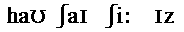 !
3. 
4. 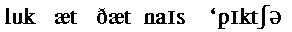
5. 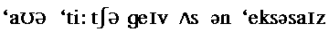
6. 
7.

1. Which is correct?
satellite
sattelite
satelite
sattellite
2. Which is correct?
accomodation
acommodation
accommodation
3. Which is correct?
finaly
finnaly
finnally
finally
4. Which one is correct?
brocolli
brocoli
broccoli
5. Which is correct?
sacreligious
sacriligious
sacrilegious
sacrelegious
6. Which is correct?
mischeivous
mischievous
mischievious
mischeivious
7. Which is correct?
supersede
supercede
superseed
8. Which is correct?
cemetery
cemetary
semetary
cematery
9. Which is correct?
heamorrhage
hemorrhage
haemmorrhage
haemorhhage
10. Which is correct?
Cincinnati
Cincinatti
Cincinnatti
11. Which is correct?
Misissippi
Misissipi
Missisippi
Mississippi
12. Which is correct?
calender
calander
calandar
calendar
13. Which is correct?
definately
defenitely
definitly
definitely
14. Which is correct?
embarrassing
embbarrassing
embarassing
embarrasing

